For this unit, you will draw a portrait of an animal using a photo reference. You will need to have a picture of an animal with you each day in class. You can use a picture of a pet, or one that you find online or from a magazine or book. The photo can be on your phone or electronic device, or you can bring in an actual photograph.
Project Requirements:
- Must have reference with you every day!
- Drawing must fill the whole page, and focus on the animal’s face.
- The drawing must be done using pencil only. I will provide drawing pencils of varying hardness and blending sticks to be used during class time.
- You must complete at least one practice sketch (to arrange your composition/test drawing techniques) before you begin on the final paper.
Homework for this unit:
In your sketchbook, draw two value scales (see example below). One value scale should be shaded and the other value scale should be done using cross-hatching to create values.
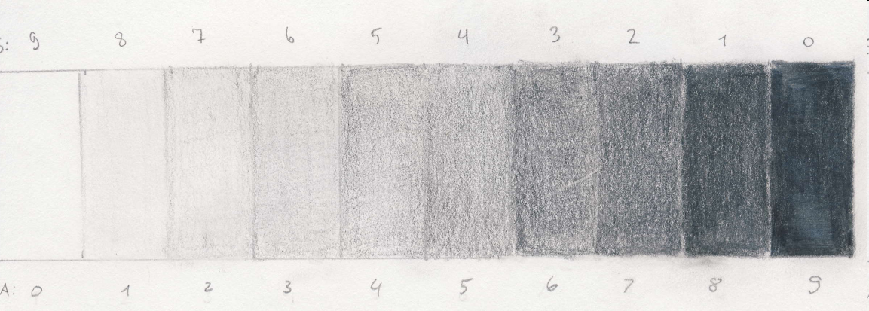
Sketchbook Assignment #4:
- Find various objects that have an interesting texture. In your sketchbook, divide a whole page into four quadrants. In each quadrant, draw a texture from one of your chosen objects (zoom in—only capture the texture on the object, not the whole object).
- Some ideas for interesting textures: nature, such as trees, plants, rocks, etc.; children’s toys; things from the ocean, such as starfish, sea shells, sand dollars, and coral (if you have dried out ones); fruits, vegetables, etc.
Project and Sketchbook #4 Due Date/In-class Critique: Thursday, September 24th, 2015
*Project examples will be posted soon, as they are in storage.*

