For this project, you will assemble and draw your own still life. You will need to choose at least 3 objects for your still life that have personal meaning. The drawing must be completed using charcoal and chalk.
Project Requirements:
- Final drawing paper will be provided in class.
- Must complete preliminary sketches in sketchbook before beginning on final project.
  - Sketches must show at least two different compositions using your chosen objects.
- Final drawing must show a range of value tones: highlights, middle tones, and deep shadows.
- You must include a background (as in show that the objects are not just floating in space).
  - Consider where you set the objects—this is important and is interpreted as part of the meaning of your artwork. For example, if you choose a hair brush, mirror, and make-up, it would make sense that your objects are in a bathroom, and not just sitting on some random table.
- You can bring your objects in to draw them or use reference images (from your personal phone, camera, or printed copies; don’t ask me to look things up on the internet for you [if you use photos, make sure your light source is consistent for the objects and background]).
- Consider choosing objects that tie together with a theme.
Project Due Date/In-class Critique: Thursday, September 3rd, 2015 [subject to change depending on the class]
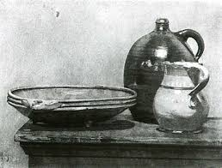
Project Examples:
